1. **INTRODUCTION**

Project Description:

TravelTrax Tours, a tour operator, leverages Zoho Books to manage their bookings, track expenses, and handle invoicing for their customers. They can generate professional invoices, reconcile payments, and monitor their financial performance. Zoho Books helps them streamline their financial operations and enhance customer service.

* 1. **PURPOSE**

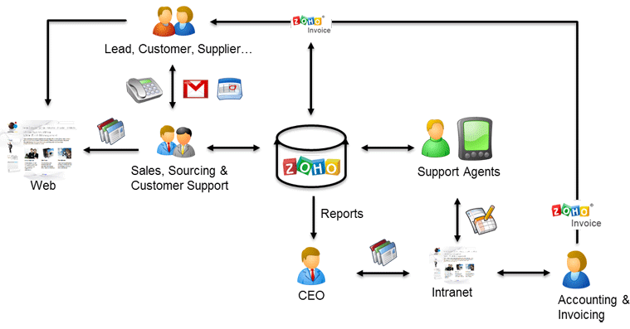Problem definition & design Thinking

* 1. Empathy map

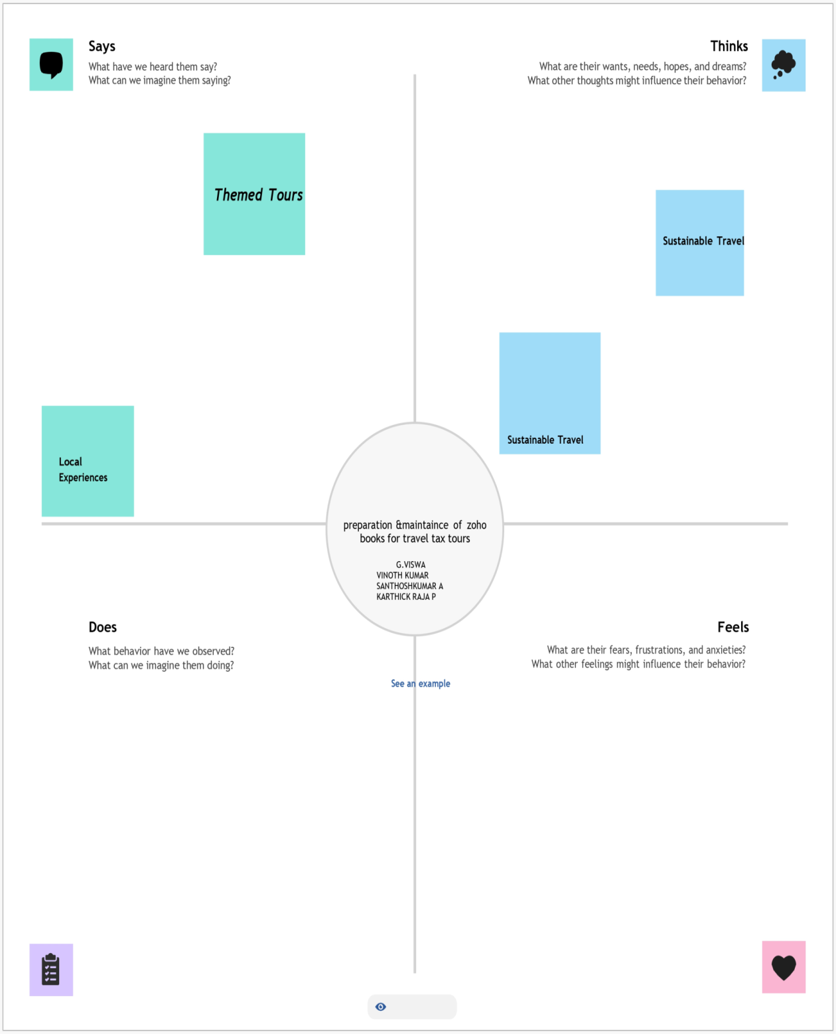

* 1. Ideation & Brainstorming map

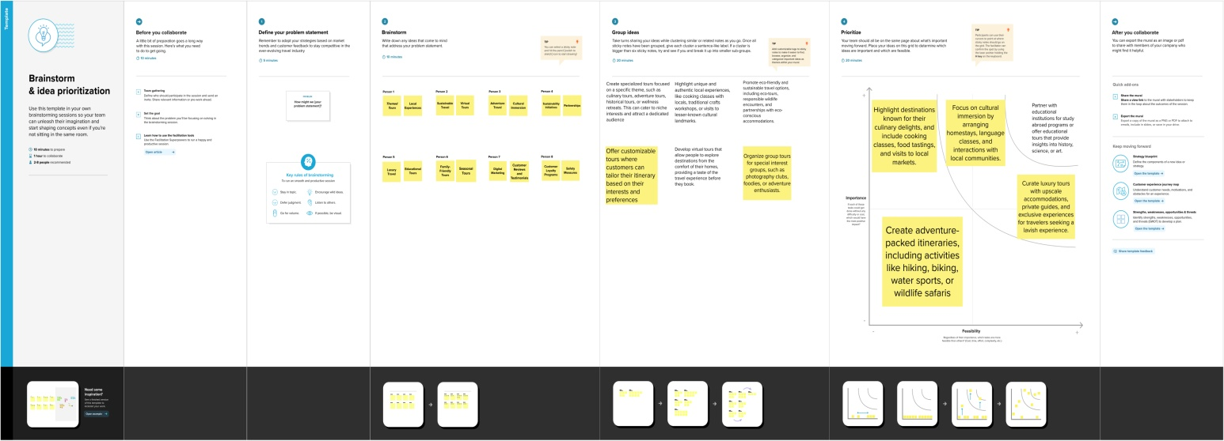

1. **Result Profit&loss**

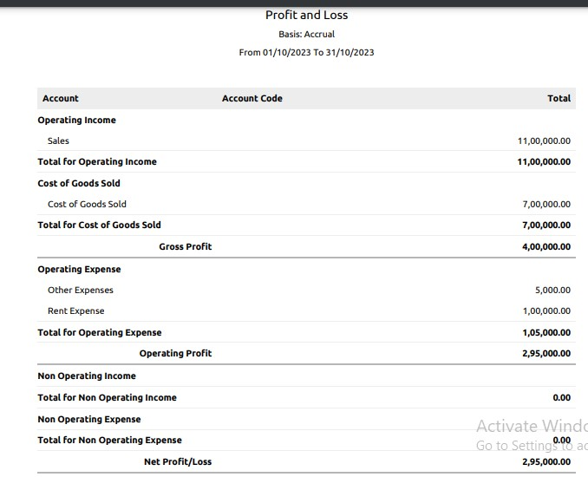

1. Balance sheet:

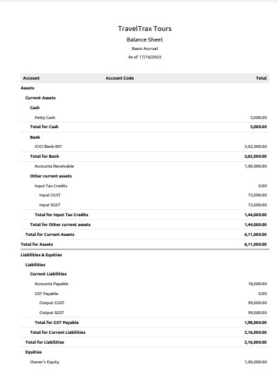

1. Purchase order:

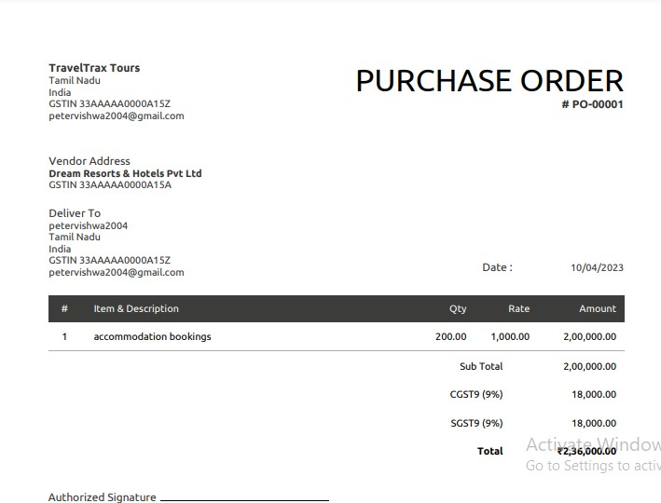

ADVANTAGES OF TRAVELTRAX TOURS (HOSPITALITY AND TOURISM-INDUSTRY)

A typical tour package will usually include plenty of destinations. Chances are that going to all these places on your own would cost a lot more, mainly because travel agents and tourism companies have good connections with the hotels and transportation companies, and also because they get maximum discounts for sending groups rather than individuals or single families.

One of the biggest advantages is of course the convenience. As earlier suggested, planning for a full-fledged trip and visiting various places will take quite a lot of planning and due diligence. But when you opt for a tour package, you can just sit back and relax — at least as far as planning is concerned.

You will be able to relax and enjoy your travel and the places without having to worry about the tickets, and hotel reservations in your next stop

DISADVANTAGES OF TRAVELTRAX TOURS (HOSPITALITY AND TOURISM-INDUSTRY)

The biggest disadvantage of a tour package is the lack of control. You need to follow the guidelines and a strict schedule. You cannot extend your stay in a certain place even if you love it. Similarly you cannot move to the next place if there’s nothing to be excited about, before the scheduled time.

You need to be extra careful while choosing one of these packages. The aforementioned advantages can easily turn into disadvantages if you don’t choose the right company.

You will have to be a little flexible with your dates and timings, in case you are looking to leave and arrive back on certain dates. You might find it hard to find an appropriate trip with the same time frame.

APPLICATION:

TravelTrax Tours(Hospitality and Toursim - industry)

CONCLUSION:

As we have seen in this chapter, tourism is a complex system that is built up of industry sectors including accommodation, recreation and entertainment, food and beverage services, transportation, and travel services. It encompasses domestic, inbound, and outbound travel for business, leisure, or other purposes. And because of this large scope, tourism development requires participation from all walks of life, including private business, governmental agencies, educational institutions, communities, and citizens.

FUTURE SCOPE:

With the development of shared economy, greater emphasis is put on social well-being, as user experience slowly becomes more important than ownership. This new approach is also expressed in novel forms of payment, which can seriously decrease the profits of intermediate activities. The new trends do not seem to be problematic in the tourism industry, mostly because in this sector, the exact costs and incomes are not clearly visible yet. On the other hand, the quality development of the 3D printing technology holds a great opportunity for the tourism and hospitality sector. The development of digitalization has finally reached a level where it can truly support the cost-effectiveness and sustainability of industrial food production, paving the way to the future of tourism and hospitality businesses.